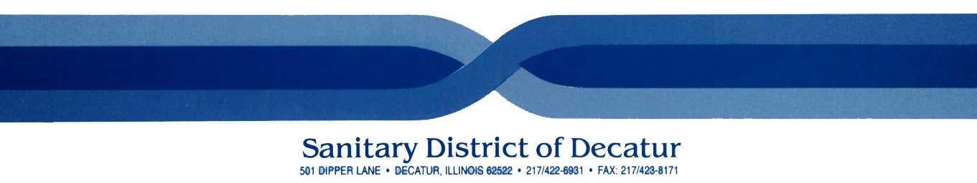
Phone Number For All Emergencies
911
In Case Of Emergency Contact Phone Operator (Base) by Radio Emergencies
911

Orphan Lock Removal Permit
I have verified that the following employee has affixed a Lock(s)/Tag(s) that must be removed and that he/she is not at the facility.

Name on Lock: _______________________________________________________

Equipment locked out: _____________________________________________________

Date: __________________________________________________________________

Method of contact: ________________________________________________________

Supervisor attempting contact: ______________________________________________

Resolution: ________________________________________________________________________________________________________________________________________________________________________________________________________________________________________________________________________

Removal Authorized By: ________________________________
I have made a reasonable attempt to contact the individual whose lock has been orphaned and have determined that the removal of the lock will pose no danger to employees, contractors, visitors, guests, property or materials. Furthermore, I will inform the employee whose lock has been removed of the action BEFORE they begin their next work shift.

Employee has been notified that their lock was removed from the equipment listed above.

Signature of Employee notified: ___________________________ Date_____________________

Due in Safety Coordinator’s office within the shift the employee was notified their lock was removed.

