Identification of Compounds or Factors Leading to Low % UVTs

In Decatur Sanitary District’s Nitrification Effluent

Abstract

A series of experiments of varying nature was conducted to try and elucidate the nature
and possible identity of compounds or factors responsible for low %UVTs in the Decatur Sanitary District’s nitrification effluent (NE). This study can be divided into the following phases: (1) performing UV scans from 200 to 400 nm on 1.5 micron filtered plant influent (I-2), nitrification effluent and major industrial effluents; Archer Daniel Midland East Sweetener (ADM ES),Archer Daniel Midland Damon (ADM Damon), A.E. Staley’s West Main (Staley WM), and A.E. Staley’s 25th (Staley 25th) to look for identifiable chromophores. These same samples were also subjected to a soluble chemical oxygen demand (COD) test so that any correlation existing between absorbance at 254 nm and COD might be identified. Also filtrates were prepared using 0.22 micron and 0.02 micron filters and scanned in order to compare their absorbances with the results obtained using 1.5 micron filters, (2) concentrating NE chromophores via C8 and C18 solid phase extraction cartridges and scanning the eluents for amplified peaks, (3) testing NE at Millikin University via reversed phase HPLC (high performance liquid chromatography), (4) using paper chromatography to search for the UV absorbing amino acids phenylalanine, tryptophan, and tyrosine, (5) blending of industrial and domestic wastewater to determine the closeness of fit of actual, blended absorbances to linear, predicted absorbances, (6) looking for relationship between dissolved organic carbon (DOC) and %UVT in NE, PE (primary effluent) and major industrial samples, (7) investigating the relationship between turbidity and absorbance for unfiltered and 0.45 micron filtered NE, and finally (8) studying colloid participation in lowering %UVTs by treating NE with the coagulants aluminum chloride hexahydrate (AlCl_{3.} 6H₂O) and ferric chloride hexahydrate (FeCl_{3.} 6H₂O).

Introduction

The ability of a compound to absorb light in the near ultraviolet region, 200-380 nm, depends on the type of chromophore that is present on its electronic structure¹. A chromophore is that part of a molecule which is responsible for light absorption in the visible and near ultraviolet. Examples of chromophores are the covalently unsaturated groups C=C, C=O, and NO₂. Scanning a sample between the above mentioned wavelengths would produce an absorption band with specific position and intensity if an absorbing solute, with adequate concentration and a specific chromophore, is present in the sample. The relationship between absorption (A), the transmittance (T), the thickness of the medium (b), and the concentration of the absorbing solute (c) is given by Beer’s Law:

A = abc = -log T Equation (1)

In this equation, (a) is the absorptivity, which is a proportionality constant characteristic of the absorbing material at the wavelength of interest².

It is reported by the USEPA³ (see Table 1 below) that the typical %UVT range for secondary wastewater effluent is 60 –74 %. The Sanitary District of Decatur’s nitrification effluent rarely has a %UVT over 60 % unless diluted by rainfall. If compounds or factors that create such large UV demand in the District’s effluent could be identified, remedial action might then be established.

Table 1. Typical Percent UV Transmittance
Values for Wastewater
Wastewater treatment level | Percent  Transmittance
Primary | 45-67
Secondary | 60-74
Tertiary | 67-82

Source: USEPA, 1986.

Initially, in this study, NE samples were scanned in the near ultraviolet range in an attempt to identify the solutes that create such a low % UVT. Scans of major industries and influent samples were also performed for comparison purposes. Absorbance rather than % UVT was often used as measure of UV demand of the samples because, as shown by Beer’s Law above, it has a linear relationship with the concentration of the absorbing solute. Percent UVT can be calculated from absorbance by the following formula:

% UVT = 10^{2-A} Equation (2)

Some classes of organic compounds such as sugars and starches were not investigated in this study because they lack aromaticity and conjugated double bonds, which are the main causes of light being absorbed in the UV range of interest.

COD tests were performed on various filtered plant and major industrial samples. According to Standard Methods ⁴, COD is a measure of the oxygen equivalent of the organic matter content of a sample that is susceptible to oxidation by a strong chemical oxidant. The more oxidizable material present in a sample the higher the COD value will rise, and in sewage sample the major part of oxidizable matter is organic. However, the absorbance may not rise correspondingly because some organic substances such as sugars and starches are non-absorbers at 254 nm as mentioned above. Every organic chemical has its unique absorptivity at 254 nm. In the organic soup that exists in a wastewater effluent, it may be difficult to discern a consistent pattern between COD and absorbance as the “soup” ingredients may change from day to day as well as their concentrations.

Adequate concentration of a compound of interest is important for its ease of identification. Techniques have been developed to help achieve this. One of the new techniques that is now widely used for this purpose is Solid Phase Extraction (SPE). In SPE the substance of interest that is in low concentration in a sample is isolated and retained (concentrated) on the absorbing material in the solid phase column and later released by using a small amount of appropriate solvent. This technique is also useful in removing interfering materials in the sample⁵. The solid phase extracting materials used in this study (C8 and C18) are both non-polar silica phase sorbents that are designed for non-polar extractions in an aqueous matrix. Thus the compounds containing chromophores of interest that absorb at 254 nm such as aromatic rings should be captured and concentrated by the C8 and C18 sorbents.

Reversed phase HPLC (High Pressure Liquid Chromatography) incorporates the same sorbents used in SPE but in an enclosed, pressurized system. Two solvents are generally used in reversed phase HPLC : water and either methanol or acetonitrile. The basic principle of reversed phase HPLC is that organic compounds will stick to the column in high aqueous mobile phase and are eluted later in high organic mobile phase⁶. For that reason, the run is started with a high percent water mobile phase and gradually shifted over time to 100 % methanol. The more hydrophobic a compound is the stronger it will bond to the stationary phase resulting in a longer retention time.

Because a major part of the District’s influent comes from the two major food -processing industries located in Decatur, naturally, attention was drawn to them as a possible source of chromophores. The raw materials of corn and soybeans are an excellent source of amino acids, peptides, and proteins. Samples containing amino acids with aromatic side chains (i.e. tryptophan, tyrosine, and phenylalanine) can exhibit strong UV-light absorption in proportion to their concentration⁷.

When the HPLC (high pressure liquid chromatography) work at Millikin University was done, it was decided to test the samples for amino acids using paper chromatography in an effort to qualitatively determine the presence of the three aromatic amino acids. The paper chromatography method in conjunction with the ninhydrin color test is widely used in the identification of amino acids. The sensitivity of ninhydrin to amino acids is demonstrated by its use in detecting amino acids in latent fingerprints in forensic police work.

All amino acids with the exceptions of proline, hydroxyproline, and o-, m-, and p- amino benzoic acids, which yield a yellow color, react with ninhydrin to produce a blue to blue-violet color⁸. A positive ninhydrin test result together with the R_{f} (retention factor) value obtained during paper chromatography procedures can be used to positively identify an amino acid. The retention factor is defined in Equation 3 below.

Retention Factor (R_{f}) = | Distance traveled by sample spot | Equation (3)
Retention Factor (R_{f}) = | Distance traveled by solvent front | Equation (3)

Dissolved Organic Carbon (DOC) is organic material from plants and animals broken down into such a small size that it is “dissolved” into water. Some DOC molecules, as a result of this breakdown, have a recognizable chemical structure that can easily be defined (such as fats, carbohydrates, and proteins). However most have no readily identifiable structure and are lumped under the term humic or tannin substances⁹.

For any sample, the ratio of absorbance at 254 nm to DOC is an important index, and if that ratio is multiplied by 100, it is called SUVA (Specific Ultraviolet Absorbance)¹⁰:

Absorbance (cm⁻¹) | X | 100 cm | = SUVA (L mg⁻¹m⁻¹) | Equation (4)
DOC (mg/L) | X | m | = SUVA (L mg⁻¹m⁻¹) | Equation (4)

There is a strong linear relationship between SUVA and aromaticity¹¹ of the sample. It is also reported that SUVA is an indicator of the humic content of water¹². The amount of aromatic character in NE is important to this study because that is one of the main reasons why light is absorbed by organic molecules.

Turbidity is an expression of the optical property that causes light to be scattered and absorbed rather than transmitted with no change in direction or flux level through the sample⁴. Therefore, by comparing the absorbance and turbidity of filtered and unfiltered samples, the effect of particle size and turbidity on the absorbance may be understood.

Colloidal dispersions of solids in water are of two types: hydrophobic and hydrophilic. The hydrophobic colloids are charged particles. The charge on all colloidal particles within the dispersion is the same. Most metallic oxide colloidal dispersions are positively charged, while the non-metallic oxide and metallic sulfide dispersions are usually negatively charged¹³. The size of the colloids range from1 micron down to 0.001 microns¹⁴. They do not naturally settle out or aggregate due to repulsion of like charges and their small mass to surface area ratio.

There are many methods to overcome the effect of charge on dispersions in order to settle them. However, the use of inorganic salts of iron and aluminum as coagulants is the most common one. The number of charges on the cations and anions of the coagulant, as well as the hydroxide concentration in the sample, each play an important role in removing the colloidal matter from the sample. Coagulants with more positive and negative charges are more effective than smaller charged coagulants in removing colloidal matter from water.

In this study we investigated the presence and type of colloids in NE and their role in %UVT reduction by using aluminum chloride hexahydrate and ferric chloride hexahydrate as coagulants.

Experimental

- Equipment/Instrumentation

  - AquaMate v4.60 UV/VIS spectrophotometer
  - Beckman DU 530 UV/VIS spectrophotometer
  - Hach model DRB 200 block digester
  - HF Scientific DRT -15CE Turbidimeter
  - Kjeldahl distillation and digestion unit
  - Mettler AE 163 analytical balance
  - Perkin Elmer Series 400 Liquid Chromatograph
  - Remington Supersonic Dryer
  - Star Instruments model 100 TOC Analyzer
  - Thermo Orion model 720 Aplus pH/ISE meter

- Testing Materials and Chemicals

- Acetic acid, glacial
- Aluminum chloride, hexahydrate
- 3-aminobenzoic acid
- 4-aminobenzoic acid
- B & J Solid Phase Extraction C8 columns, 1000mg, 8 mL capacity
- B & J Solid Phase Extraction C18 columns, 1000mg, 8 mL capacity
- Borate Buffer (9.5 g sodium borate, 176 mL 0.1N NaOH diluted to 2L)
- Boric acid (1%) with mixed indicator
- n-butanol
- Digestion reagent (420 mL H₂SO₄, 268 g K₂SO_{4 ,} 5 g CuSO₄ dilute to 2L)
- Drummond Wiretrol calibrated micropipets, 5uL capacity
- Fisherbrand PVDF syringe filters, 0.22 micron pore size, 13 mm diameter
- L-hydroxyproline
- Methanol, Karl Fischer grade
- Ninhydrin
- L-phenylalanine, tissue culture grade
- Potassium acid phthalate (KHP)
- L-proline, tissue culture grade
- Sodium hydroxide / Sodium thiosulfate reagent (LabChem brand)
- L-tryptophan, tissue culture grade
- L-tyrosine, tissue culture grade
- Whatman 934-AH glass microfiber filters, 1.5 μm pore size, 47 mm diameter
- Whatman Anotop inorganic membrane filters, 0.02 μm pore size, 25 mm dia.
- Whatman cellulose nitrate membrane filters, 0.45 μm pore size, 47 mm diameter
- Whatman Grade 1 CHR Paper, 20x20 sheets
- Wheaton Chromatography fine mist spray bottle
- Wheaton Glass TLC Developing Tank

C) Procedure

Phase I – Chromophore Identification, COD-Absorbance Relationship,
and Particle Size-Absorbance Relationship

Twenty four hour composite samples were collected daily from ADM’s ES, ADM’s Damon, Staley’s West Main, Staley’s 25th, and SDD’s influent. Daily grab samples were collected from SDD’s nitrification effluent. All samples were filtered thru a 1.5 micron, glass fiber filter prior to scanning from 200 to 400 nm. Each analysis day, a blank consisting of deionized water was scanned to establish a baseline. A 50 mg carbon/L KHP standard was scanned daily to verify acceptable spectrophotometric precision at 254 nm. A graph of absorbance vs wavelength was generated for each scan. The filtered samples were also analyzed for COD so that the relationship between absorbance and COD could be studied. As a further step, the filtrates from the 1.5 micron filtration were passed thru a 0.22 micron filter, and in the last ten trials the filtrate was further passed thru a 0.02 micron filter to see how this affected the absorbance readings and graphical profiles of each sample.

Phase II – Solid Phase Extraction

Nitrification effluent samples were filtered thru 0.45 micron membrane filters. Then the filtrates were applied to C8 or C18 SPE cartridges to increase the concentration of the analytes. The part of the sample, which passed thru the C8 or C18 cartridges un-retained, was scanned first. Then the concentrated analytes that were captured on the solid phase were released by application of a small amount of methanol as an eluting solvent. The methanol extracts were then scanned from 200 to 400 nm to look for amplified peaks caused by the concentrating.

Phase III - Identification of UV Absorbing Compounds using HPLC

Discussions with Dr. Acheson of Millikin University about our UV research resulted in setting up a day for testing a 0.22 micron filtered nitrification effluent sample on Millikin’s reversed phase HPLC column with UV detector set at 254 nm. After injection of the sample into the HPLC, no peaks were observed. Injection of toluene confirmed proper operation of the instrument. It was hypothesized that the lack of peaks was due to amino acids being retained by the solid phase of the column. Therefore, research on the presence of amino acids was pursued using an alternate technique in Phase IV.

Phase IV – Amino Acid / Protein Identification via Paper Chromatography

Of the three aromatic amino acids, tryptophan is the strongest light absorber at 254 nm. It has the highest molar absorptivity, which is a gauge of how well a particular chemical compound absorbs light at a specific wavelength. The molar absorptivities otherwise known as molar extinction coefficients¹⁵ of tryptophan, tyrosine, and phenylalanine at 254 nm are respectively 2781, 370, and 143. Thus at the same molar concentration, tryptophan would absorb 7.5 times more light than tyrosine and 19.4 times more light than phenylalanine. An 18 mg/L tryptophan standard (0.00008814 M) was prepared as it contains 2.47 mg/L organic nitrogen which approximates the amount of organic nitrogen present in an average NE sample. The absorbance of this 18 mg/L tryptophan standard at 254 nm was 0.247. This agreed well with the theoretical value of 0.245 obtained by solving Beer’s Law (Equation 1) for A where a = 2781 cm⁻¹ M⁻¹, b = 1 cm, and c = (0.00008814 M).

Work began by placing 15 uL of 50 mg/L standard solutions of tryptophan, tyrosine, and phenylalanine on a 20x20 sheet of Whatman Grade 1 CHR paper along with 15 uL of NE sample. Application was made on a pencil line drawn 3cm from an edge of the paper. Small drops less than 0.5 uL in volume were applied using a 5 uL disposable micro pipet. After each drop was applied, a heat gun was used to dry the spot before the next drop was added. When sample application was completed, the chromatography paper was suspended inside a glass development tank containing about a one half- inch layer of mobile phase (60% butanol / 15 % glacial acetic acid / 25 % water). The paper was suspended so that the bottom edge was immersed about 1 cm into the mobile phase being careful that the pencil line containing the dried sample spots was not immersed in mobile phase. A lid was placed on the chromatography tank to keep mobile phase vapor pressure as high as possible. The mobile phase was allowed to travel up the paper by capillary action for about 1.5 to 2 hours until the rate of travel of the solvent front came to a near standstill. The sheet was then removed from the development tank, and the solvent front was marked with pencil marks. The sheet was hung up in a hood and dried with a hair dryer. After drying, the sheet was sprayed with 1% ninhydrin in butanol. The chromatogram was then dried again using a hair dryer and then placed in a 70° C oven for 5 minutes. Light violet spots developed for tryptophan, tyrosine, and phenylalanine and a yellow spot for NE. The R_{f} value was calculated for each of the three standards and NE. This general procedure was used for all subsequent paper chromatography work. Because the standard spots were faint in color, the concentration of the standard solutions was increased from 50 to 200 mg/L for all subsequent work. The amount of NE applied in subsequent work was also increased to 25 μL (a 40 % increase). Other sample sources investigated by paper chromatography included primary effluent, Lost Bridge pump station (domestic wastewater), ADM ES, ADM Damon, Staley WM, and Staley 25th. Yellow spots were observed for all sample sites but no violet spots. Only two amino acids (proline and hydroxylproline) give yellow spots. However, neither of these two amino acids absorbs light at 254 nm. Standards were obtained for these two amino acids and chromatographed against plant and industrial samples to compare R_{f} values.

In another experiment, a NE sample was concentrated 11.6 times prior to applying it to the paper to enhance the chance of observing blue-violet amino acid spots. Concentrating was accomplished by evaporating 750 mL of the sample maintained at 62 –63° C until a final volume of 64.7 mL was achieved.

Also three non-amino acid compounds ( ortho, meta, and para amino benzoic acids) were investigated via paper chromatography because they also are UV absorbers and react with ninhydrin to form yellow spots.

In the following phases of this study, factors which influence UV absorbance in aqueous medium were investigated.

Phase V – Effect of Industrial Sewage on Absorbance of Domestic Sewage

To see what effect industrial wastewater could have on the UV absorbance of domestic wastewater (Lost Bridge pump station sample), a series of mixtures was prepared by blending samples over a period of two weeks. All samples were filtered thru a 0.45 micron membrane filter prior to blending. Samples of the four major industrials (ADM ES, ADM Damon, Staley West Main, and Staley 25th) were mixed individually with domestic wastewater at a rate of 33.3 % industrial to 66.7 % domestic so that the effect of each major industrial could be studied on an individual and equal basis. In a flow-proportioned test conducted simultaneously, the following approximate percentages were used (45 % ADM ES / 55 % domestic; 41 % ADM Damon / 59 % domestic; 29 % Staley WM / 71 % domestic; and 7 % Staley 25th, 93 % domestic). For both the equal and flow proportioned tests, absorbances were measured on all mixtures and on all mixture components.

Phase VI - Relationship between DOC and Absorbance

In this phase dissolved organic carbon (DOC) and absorbance values for 0.45 micron filtered samples of major industries, domestic wastewater (Lost Bridge pump station), NE and PE were measured and compared. DOC of the filtered samples was measured using a
Star Instruments model 100 TOC analyzer. These parameters were also used to calculate SUVA in order to determine the aromaticity of the samples.

Phase VII – Relationship between turbidity and UV absorbance at 254 nm

Turbidity and absorbance at 254 nm were measured on both unfiltered and 0.45-micron filtered grab NE samples using HF Scientific DRT-15CE turbidimeter and AquaMate v4.60 UV/VIS spectrophotometer during 23 trials to study their relationship.

Phase VIII – Presence and effect of colloids and humic substances on UV absorbance

The coagulants aluminum chloride hexahydrate and ferric chloride hexahydrate were investigated for their ability to remove colloids from the nitrification effluent and other sample sites. Varying amounts of aluminum chloride hexahydrate or ferric chloride hexahydrate were added to 600 mL of NE to determine what concentration of coagulant removed the most absorbance. After adding the coagulant, the mixture was stirred vigorously for one minute and then allowed to settle. Before absorbances were measured on the supernatant, it was passed thru a 0.45-micron filter to remove a small number of unsettled flocs. P^{H} was also measured on each test sample in order to track its role in coagulation.

As an addendum to the coagulation work, the % reduction in organic nitrogen at optimal conditions for absorbance reduction via ferric chloride coagulation was studied by subjecting ferric chloride treated NE and untreated NE to the macro-Kjeldahl method⁴ for organic nitrogen determination.

Results and Discussion

Phase I – Chromophore Identification, COD-Absorbance Relationship, and Particle Size- Absorbance Relationship

The UV scans performed in the initial phase of this study did not produce results that could be used to elucidate the identity of chromophores in the nitrification effluent or other sample sites. The scans were universally of a ski slope nature with high absorbance at 200 nm and a rapid decline in absorbance to around 240 nm. Above 240 nm, the steepness of the slope lessened and nearly flattened out. The nitrification effluent as well as other samples that were examined probably contain many UV absorbing compounds but at concentrations below the detection limit of the spectrophotometer. Of the many scans that were performed, Graphs 1 thru 6 represent typical results for plant and industrial samples. From these graphs it can be seen that at wavelength 254 nm, Staley’s WM discharge had the maximum absorbance, and NE’s absorbance was the lowest. Also see Table 2 below (page 17) for detailed data on absorbance and %UVT.

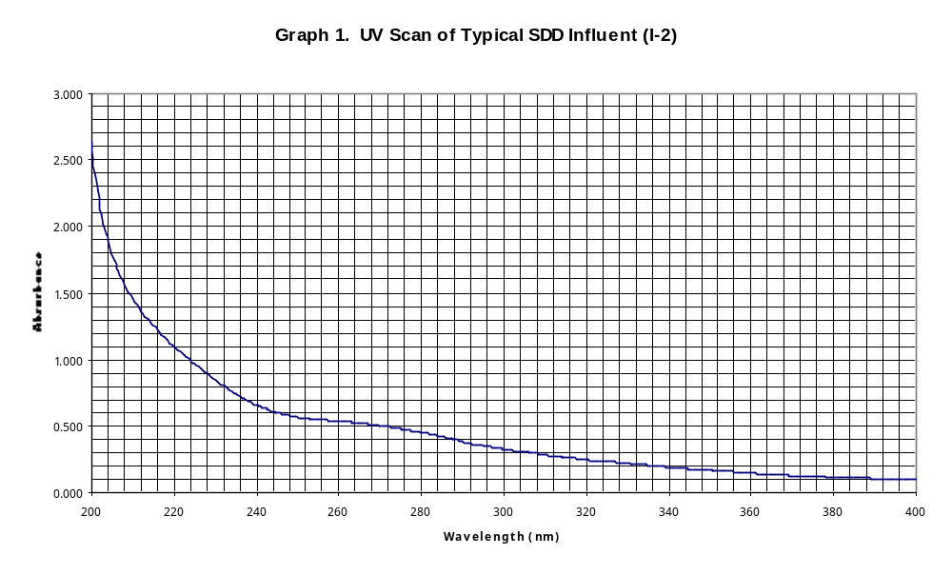
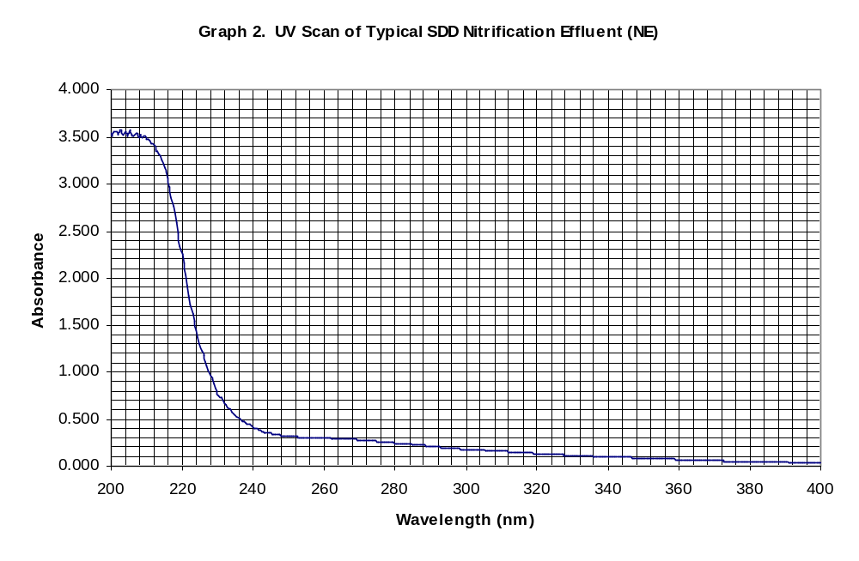

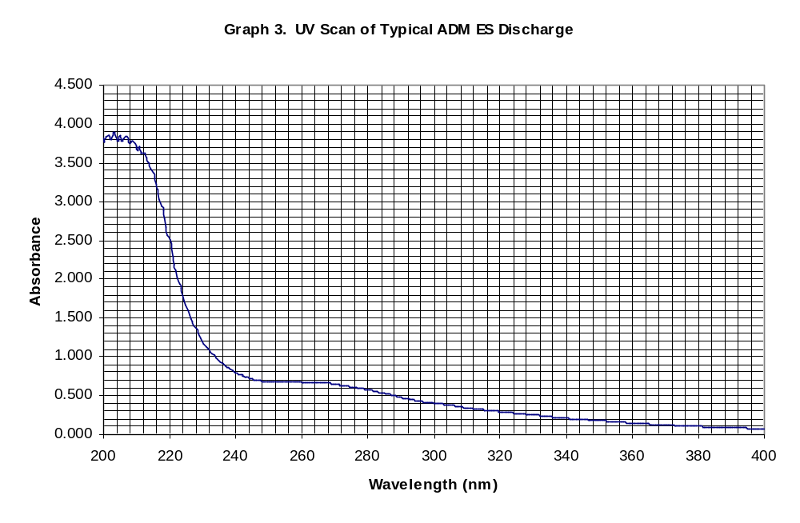

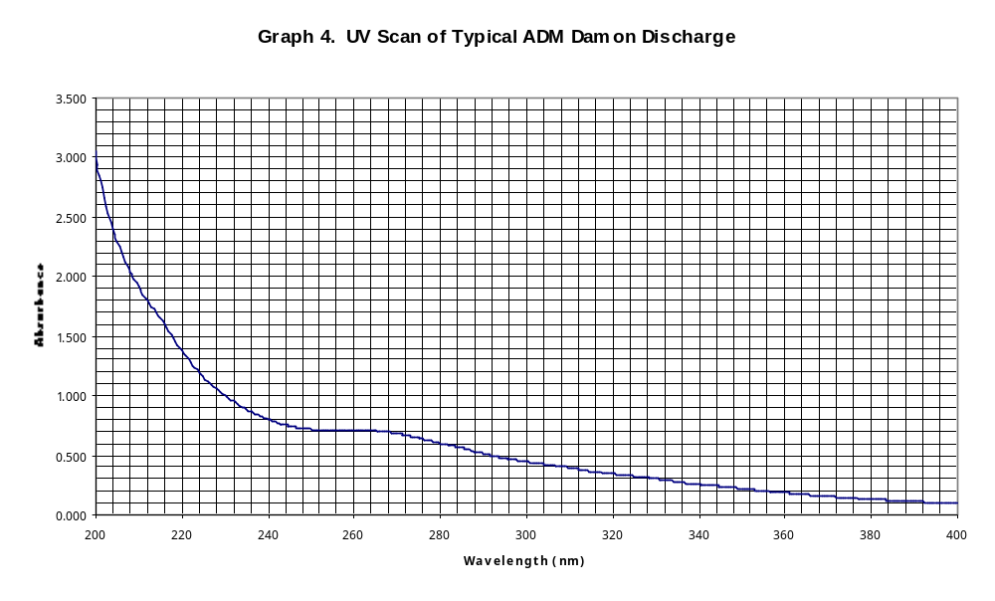

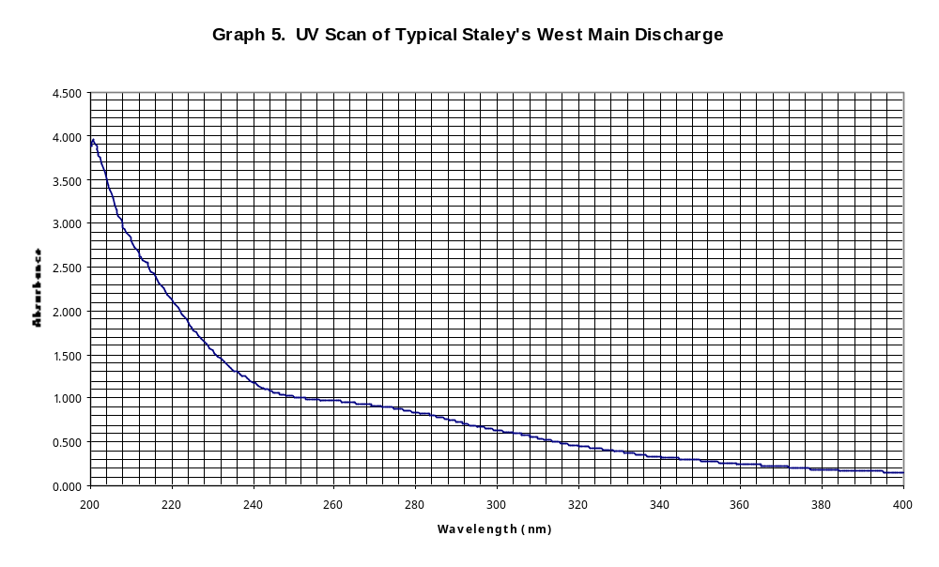

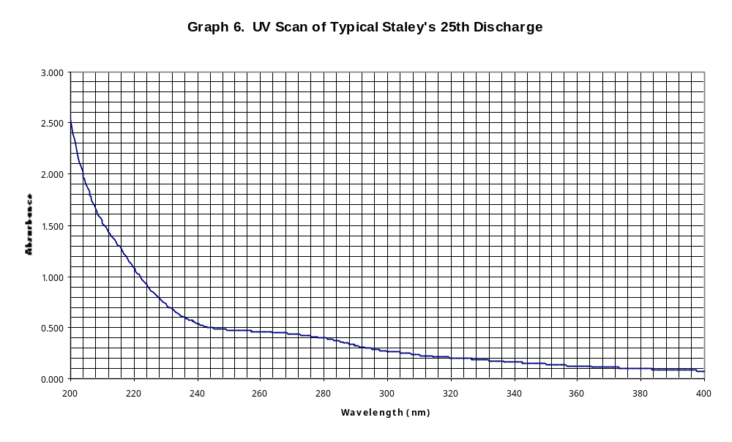

Absorbance and soluble COD values for each sample site were determined. From absorbance values their corresponding %UVTs were calculated and charted against soluble COD values to illustrate the relationship existing between these parameters. The correlation of COD values to %UVT can help in the understanding of the type of compounds that are in the wastewater. For example, a decrease in %UVT for a particular sample from one day to the next without an increase in COD may indicate an increased presence of refractory organic compounds, or inert inorganic colloids. The Graphs 7 thru 12 below show that the % UVT of each sample was generally inversely proportional to its soluble COD concentration. Values of COD and %UVT were more volatile for Staley WM and Staley 25th than for ADM ES and ADM Damon. This may be indicative of Staley’s lack of sewage storage capacity which does not allow for the leveling effect of storing sewage for many days and then releasing the homogenized discharge which is available for ADM’s discharges thru the use of their stabilization lagoons. Graph 11 for Influent (I-2) shows a direct relationship between % UVT and COD for four out the first six days of testing which is contrary to the more prevalent inverse relationship.

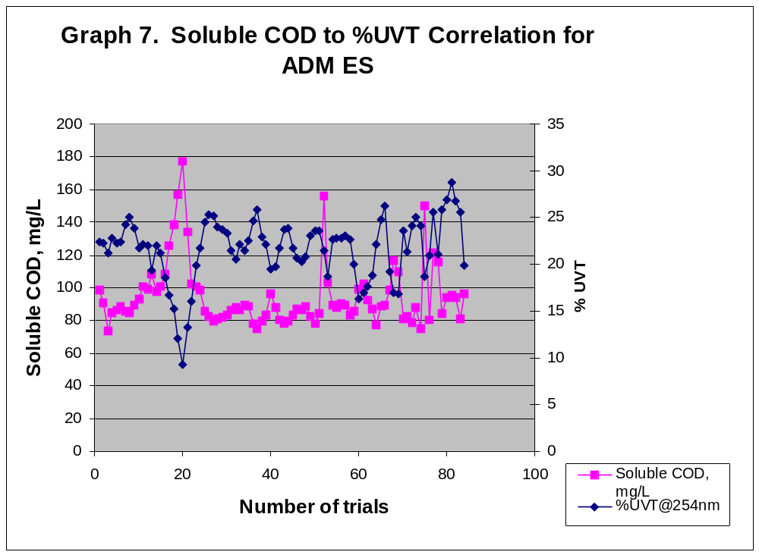

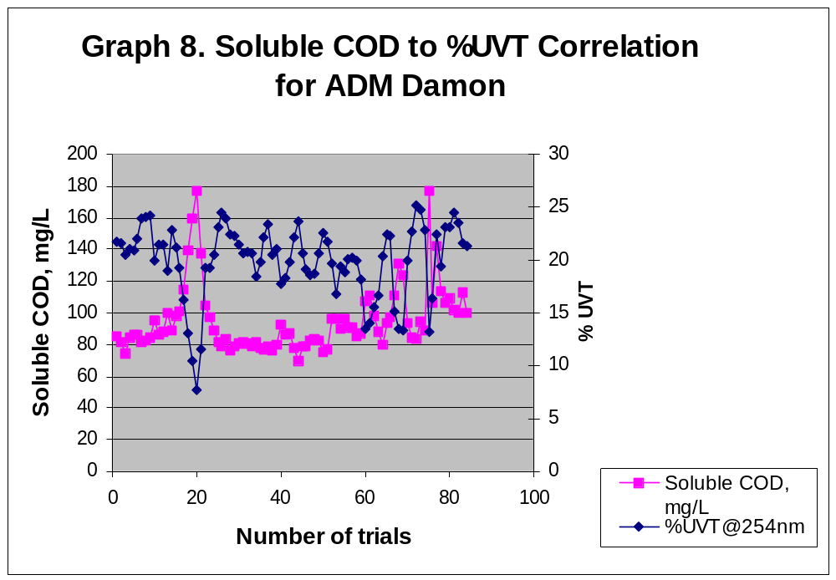

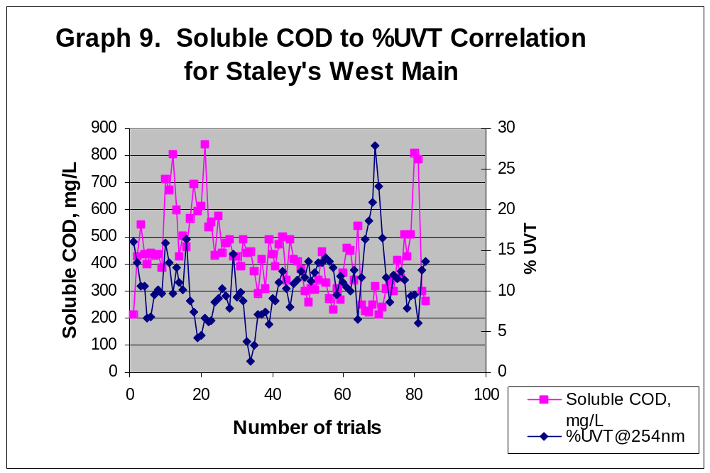

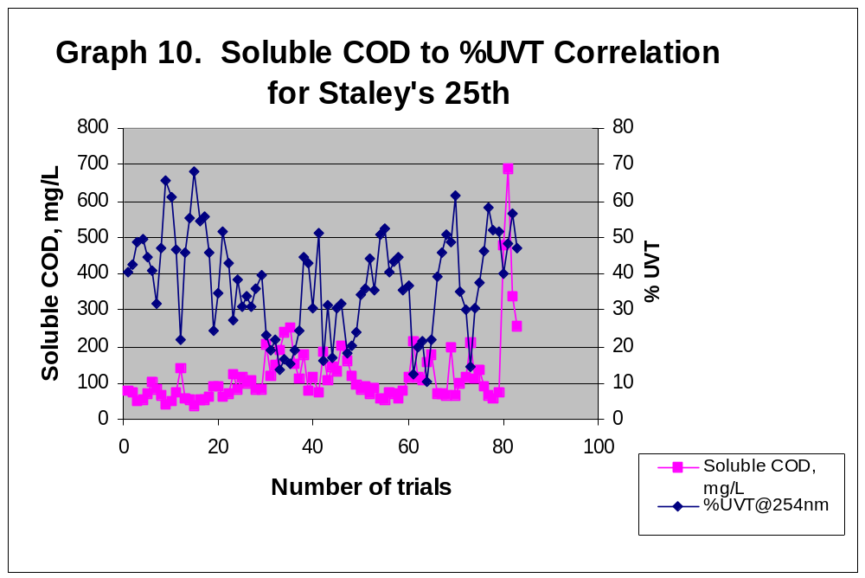
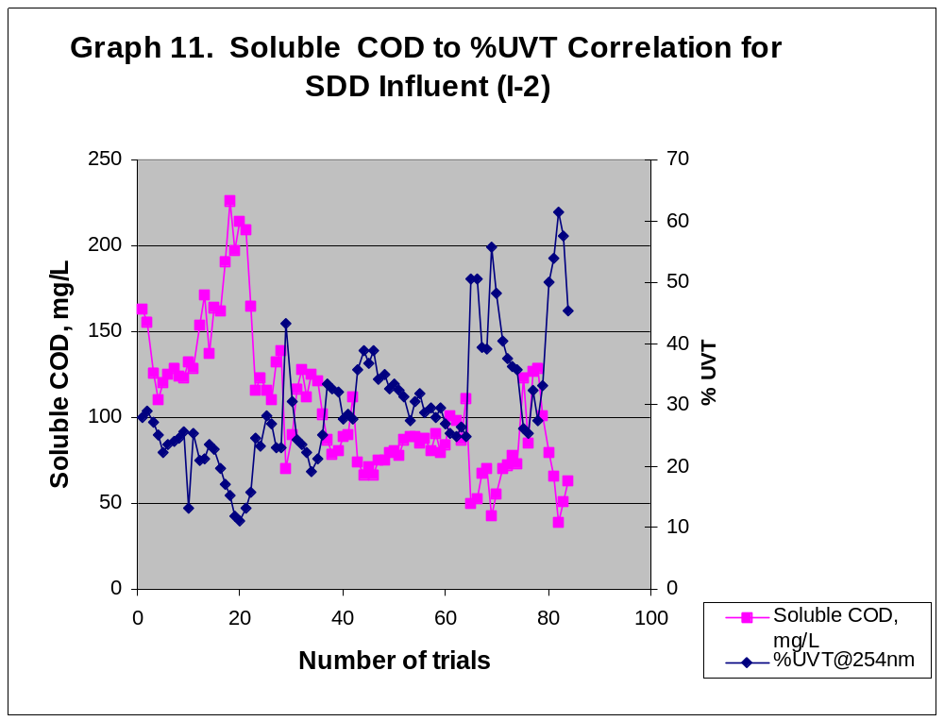

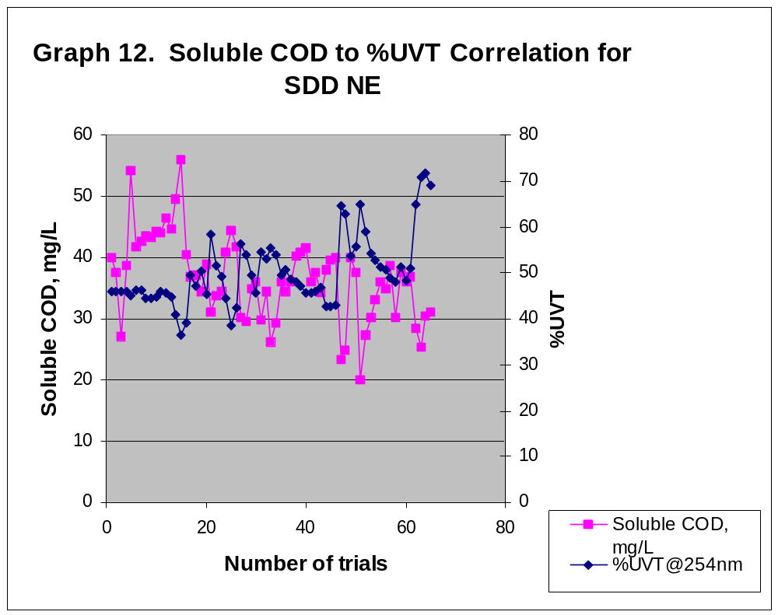From Table 2 below, it was noted that there was a 65.6 % decline in COD when going from Influent to NE but there was only a 44.2 % decline in absorbance. This may indicate that compounds that do not absorb UV light such as sugars, starches, and most amino acids were oxidized in the plant processes between influent and nitrification effluent without affecting the UV absorption of the nitrification effluent. This also suggests that besides soluble COD producing compounds, samples may contain materials that exhibit no chemical oxygen demand but yet influence absorbance. One such class of materials could be colloidal matter present in the sample that is small enough to remain in the soluble COD portion of the sample but inert in nature and thus able to resist oxidation by COD chemical reagents. The mean ratios of absorbance to COD given in Table 2 indicate that the absorbance of a sample is not always related to its oxidizable organic content.

The number of sample days for which absorbance and COD data was gathered for Table 2 was 65 for NE and 83 for influent and the four major industries. The difference in days was due to the fact the major industries and influent samples were gathered over weekends by auto sampler while NE was only gathered on weekdays by grab sampling.

Table 2. Mean Values for %UVT, Absorbance, Soluble COD, and Mean Abs / COD Ratio

Sample Location | Mean %UVT @ 254 nm | Mean Abs @ 254 nm | Mean Soluble COD, mg/L | Mean Ratio Abs/COD
Staley’s WM | 9.9 | 1.004 | 429 | 2.3 x 10⁻³
ADM Damon | 19.5 | 0.709 | 95.0 | 7.5 x 10⁻³
ADM ES | 21.3 | 0.671 | 94.6 | 7.1 x 10⁻³
SDD Influent | 28.5 | 0.545 | 106 | 5.1 x 10⁻³
Staley’s 25th | 34.3 | 0.465 | 120 | 3.9 x 10⁻³
SDD NE | 49.7 | 0.304 | 36.5 | 8.3 x10⁻³

Interference by suspended solids with the UV transmittance in wastewater is a known fact. However, in this study we investigated the influence of their size on the UV transmittance through the removal of different sized suspended solids by filtering them through progressively finer filters. Results are illustrated by graphs 13 thru 18.

The study was conducted for twenty days. During this investigation period, there was considerable rainfall, which showed up in the spike upward in the %UVT for influent and NE.

As shown by graph 18 (see page 21), there was little impact on %UVT of NE samples at 254 nm as a result of removing particulates sized between 1.5 micron and 0.02 micron. Thus it can be inferred that only a very small amount of UV absorbing particulate matter exists in NE, which is larger than 0.02 micron diameter. Rather particulate sizes that interfere with %UVT may be smaller than 0.02 micron such as colloidal matter. The subject of colloidal matter is investigated elsewhere in this study.

On the other hand, industrial samples such as Staley’s WM and SDD influent showed considerable improvement in %UVT by removing suspended solids larger than 0.02 micron as shown in Table 3 and Graphs 15 and 17 below. Table 3 covers the last 10 days of the 20-day investigation period.

Table 3. % Improvement in %UVT With Increasingly Finer Filtration of Plant and Major Industrial Samples

Sample Source | Ave %UVT for filtrates with particles <1.5 um | Ave %UVT for filtrates with particles <0.22 um | Improvement in %UVT for 0.22 um over 1.5um filtration  (%) | Ave %UVT for filtrates with particles <0.02 um | Improvement in %UVT for 0.02 um over 0.22 um filtration  (%) | Overall % improvement in % UVT
ADM ES | 23.99 | 26.98 | 12.46 | 28.12 | 4.22 | 17.2
ADM Damon | 20.84 | 24.38 | 16.99 | 25.39 | 4.14 | 21.83
Staley WM | 10.75 | 18.54 | 72.46 | 20.0 | 7.87 | 86.05
Staley 25th | 47.30 | 55.37 | 17.06 | 55.81 | 0.79 | 17.99
SDD Influent | 41.29 | 50.12 | 21.39 | 52.31 | 4.37 | 26.69
SDD NE | 58.51 | 59.88 | 2.34 | 60.88 | 1.67 | 4.05

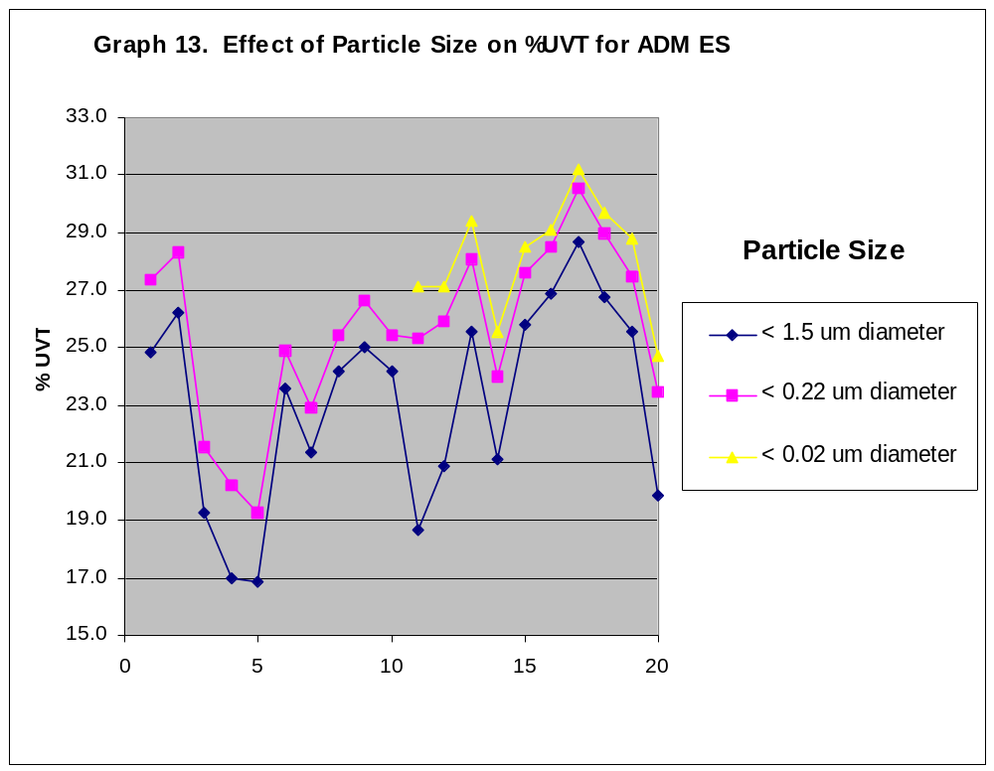
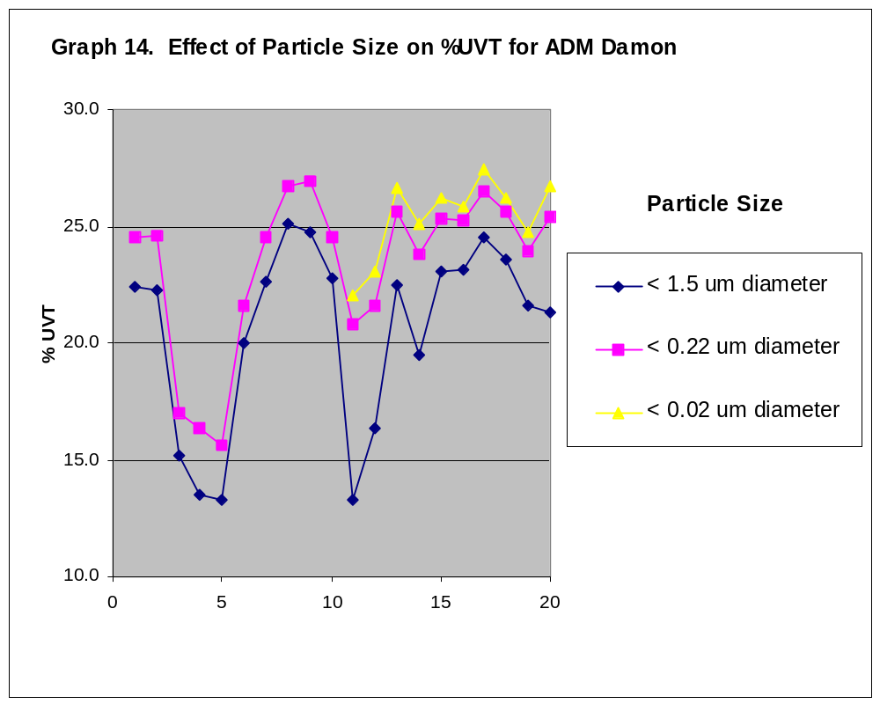

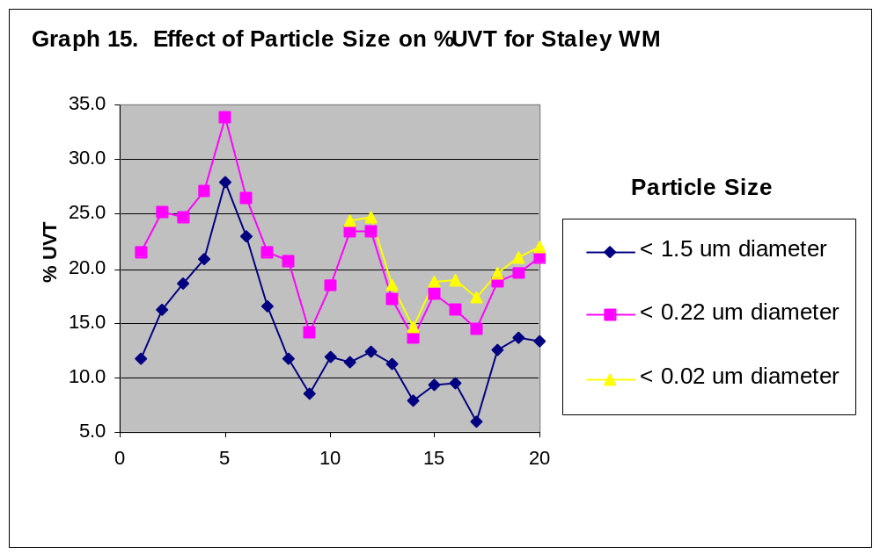

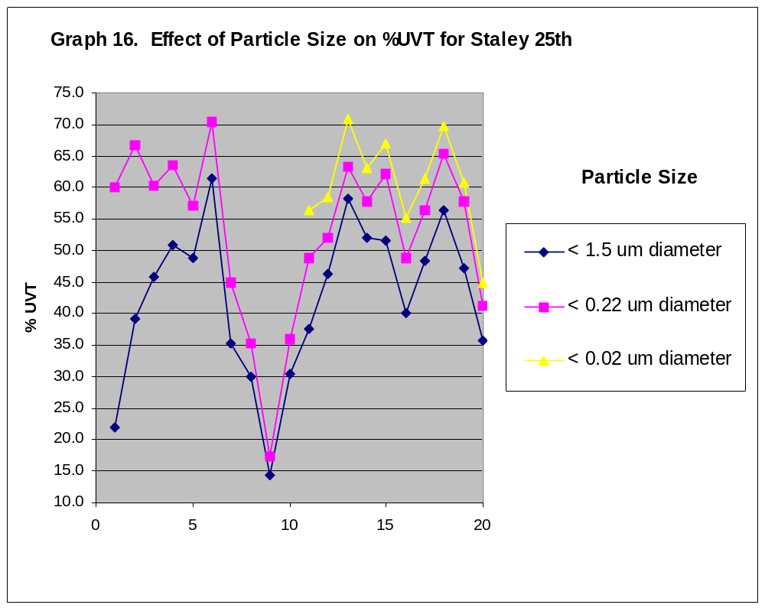

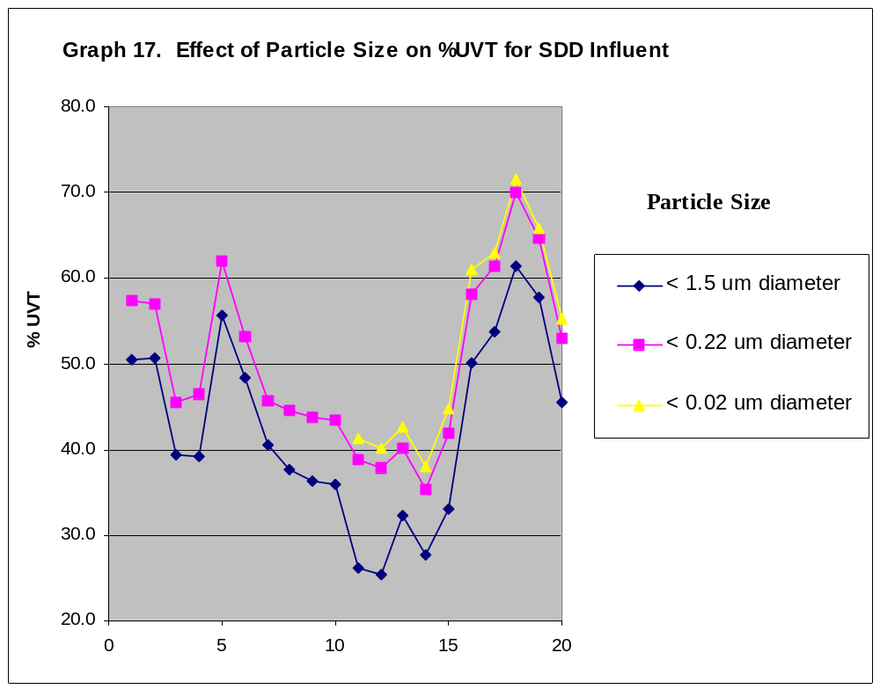

Phase II – Solid Phase Extractions
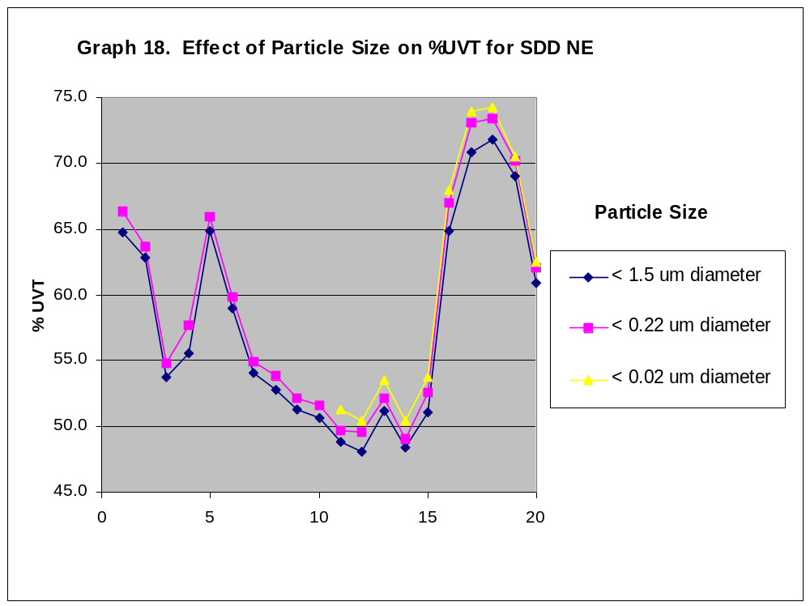
C8 and C18 solid phase extraction cartridges were used to extract and concentrate NE sample constituents. It is believed that in this process, as more and more sample was passed thru the cartridge, active sites on the solid phase were overloaded with analytes so that they were not retained completely on the solid phase but escaped retention on the cartridge. Therefore only a nominal and not a true concentration factor can be assigned to analytes that were extracted off the solid phase. When these concentrated extracts of NE were scanned, a large peak centered on 275 nm was observed. This peak that was not seen earlier in unconcentrated scans of NE possibly represents the three aromatic amino acids which besides absorbing at 254 nm also absorb more intensely at this wavelength. This preliminary evidence of amino acids (see Graph 19 below) led to the search for them and possibly other UV absorbing compounds by the use of HPLC at Millikin University as described below in Phase III. The following scan of a grab NE sample has a nominal concentration factor of 22.7 (100mL of sample eluted with 4.4 mL methanol), and the methanol extract that this scan represents was pulled off a C8 solid phase cartridge.

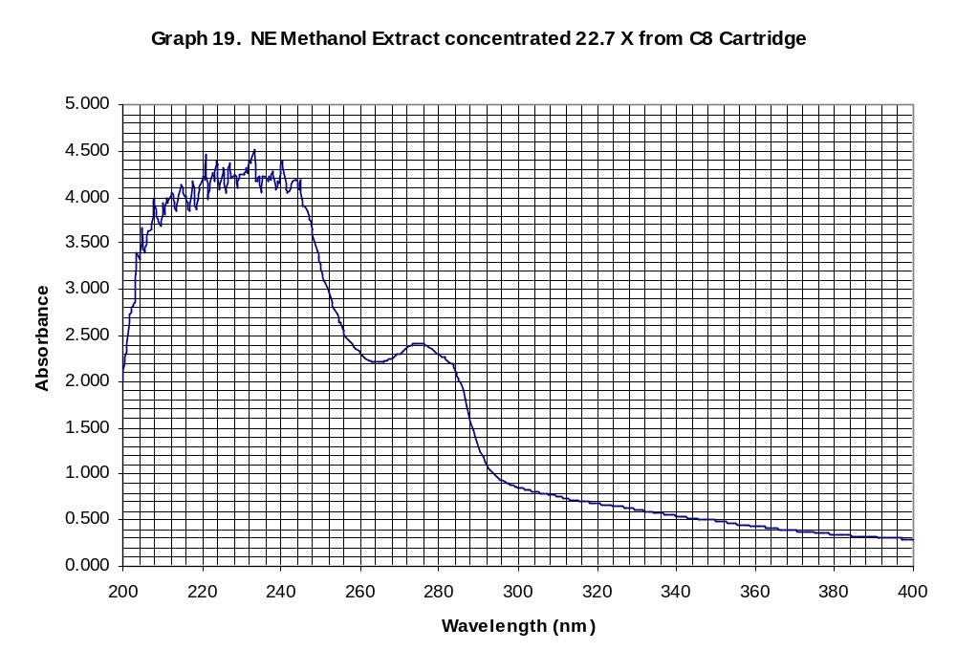
Phase III – Identification of UV Absorbing Compounds using HPLC

No peaks were detected via reversed phase HPLC at Millikin University. Prior to testing the 0.22 micron filtered NE sample at Millikin, the sample’s UV absorbance at 254 nm was measured to be 0.343 at the SDD. This is a significant amount of absorbance and represents 45.4 % light transmittance that should have been detected by the HPLC method also. One explanation for the lack of peaks in such a high absorbance sample could be that the light absorbing compounds were being irreversibly retained on the analytical or guard column, and as a result never reached the UV detector. Therefore, in Phase IV, a paper chromatography method was used to investigate the presence of amino acids in the samples.

Other possible compounds that might have been irreversibly retained on the column were humic substances, which include humic and fulvic acids. Humic and fulvic acids are ubiquitous in the environment and are formed from the microbiological and abiotic transformations of animal and plant materials. These transformations involve a two stage process of decomposition of original plant and animal residues to simpler compounds and subsequent synthesis of specific, high molecular weight substances, so called humic substances¹⁶. According to one study, 40 to 50 % of the total organic content of typical secondary effluents is humic substances of which fulvic acid predominates¹⁷. Both fulvic and humic acid are refractory compounds with half-lives of 10 to 50 years for fulvic acid and centuries for humic acid¹⁸. Since ADM and Staley process a very large amount of plant material, it is quite possible that a significant amount of humic substances find their way to the SDD nitrification effluent from these sources. The yellow tint of the SDD’s nitrification effluent may be caused by fulvic acid, which is yellow in color. Both humic and fulvic acids have highly variable molecular weights, and thus one particular structure can not account for the various fulvic and humic acids that exist. Intensive research around the world is proposed structures are shown below in Figures 1 and 2.

Figure 1: Model structure of humic acid¹⁹
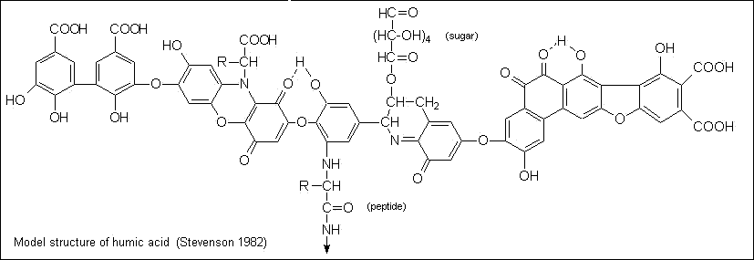

Figure 2: Model structure of fulvic acid¹⁹
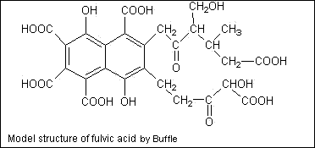

Another possible explanation for why no analytes were detected via HPLC is that
all the analytes were at concentrations below the detection limit of the UV detector. Under this scenario, many UV light absorbing compounds might be present in NE but at very low concentrations such as parts per trillion. And, of course, a combination of the two scenarios of irreversible retention and ultra low concentration could also be expected.

Phase IV – Amino Acid / Protein Identification via Paper Chromatography

The presence of amino acids in NE and other sample sites could not be detected by paper chromatography. However, since, on average, there is about 2.4 mg/L of organic nitrogen present in NE, part of it may be amino acids but at a level below detection. If the organic nitrogen in NE existed entirely in the form of the twenty common amino acids and equally distributed between them, each amino acid would only be present at a concentration of approximately 0.12 mg/L. Since the 50 mg/L amino acid standards used initially only gave a faint purple color, 0.12 mg/L would probably be undetectable. Theoretically, the absorbance of the most light absorbing amino acid tryptophan at a concentration of 0.12 mg/L would only be 0.002. Furthermore, since organic nitrogen can certainly exist in other forms than amino acids that would hypothetically drop the level of each amino acid even below 0.12 mg/L. A literature search found that free amino acids and combined amino acids only account for 0.5 % and 5 % respectively of total organic nitrogen in typical secondary wastewater effluent²⁰. If these percentages apply to the district’s effluent, then each of the twenty common amino acids would only be present at about 0.007 mg/L. The absorbance of even tryptophan at that concentration would be essentially zero.

The yellow spot seen on all NE, PE, and industrial sample chromatograms does not appear to be proline or hydroxyproline even though proline has a similar R_{f} value of ~0.40. The yellow spots for proline and hydroxyproline standards (200 mg/L) appeared within minutes upon drying and then faded greatly over a three-day period. On the other hand, yellow spots for NE, PE, major industries, and domestic wastewater never appeared immediately but developed gradually over a several day period and remained a consistent yellow color for many weeks thereafter. Also the strong evidence mentioned earlier of very low amino acid concentrations in NE would argue against the yellow spots being amino acids.

The weakest yellow spots were seen for Staley WM and Lost Bridge. The brightest, most intense yellow spot was observed for an NE sample concentrated 11.6X by heating gently at 62 – 63° C. Other chemicals that are known to produce yellow spots via paper chromatography are the isomers of amino benzoic acid (ortho, meta, and para). Standards of the meta and para isomers (ortho was commercially unavailable) were obtained and tested via paper chromatography. They yielded faint yellow spots, which appeared rapidly upon drying of the chromatogram with much different R_{f} values (meta R_{f} = 0.82, para R_{f} = 0.86) than NE’s (R_{f} ≅ 0.38). Thus it appears that no compounds known for producing yellow ninhydrin reaction products are responsible for the yellow spot seen in all NE, PE, and industrial, and domestic wastewater sample chromatograms. Other researchers have had difficulty finding the source of yellow spots on paper chromatograms as evidenced by the following quote from the Annual Review of Plant Physiology²¹, “The nature of certain yellow ninhydrin reaction products which often appear on the papers is still unknown.”

Phase V – Effect of Industrial Sewage on Absorbance of Domestic Sewage

In order to determine the effect of industrial discharges (ADM ES, ADM Damon, Staley WM, and Staley 25th) on the NE’s UV transmission capacity, the sample blending study was initiated. The effect on absorbance could simply be one of a straightforward volumetric nature with a mixture absorbance reflecting the volumetric ratios [i.e. mixture absorbance = (fractional volume of industrial sewage X its absorbance) + (fractional volume of domestic sewage X its absorbance)]. The other effect could be a retreat from predicted values caused by chemical reactions. The NE sample could not be used in this testing because it already contained the industrial discharges to be investigated. Therefore, a domestic sample site, Lost Bridge pumping station (LB), that contained none of the industry under scrutiny, was selected for this purpose.

A ratio of 33.3 % industrial to 66.7 % domestic sewage was used so that the effect of each industry on domestic sewage absorbance could be evaluated on an equal and individual basis. The changes in absorbance of domestic sewage that occurred after mixing with industrial samples are given in Table 4. It also compares the actual and predicted absorbance value for each mixture. Even though the results are in harmony with the volumetric ratios used, there is a remote possibility that chemical reactions might have taken place during mixing causing the destruction and creation of chromophores at an equal rate.

Other mixing ratios mentioned in Phase V of the procedure section of this report were also tested on the basis of their flow ratios. Percent agreements were very similar to those shown in Table 4.

Table 4. Summary Data Showing Domestic Sewage Absorbance Changes due to Combining With Industrial Discharges

Industrial Sample Added to LB  No. of Trials=11 | Average Initial Absorbance of Industrial Sample | Average Initial Absorbance of LB Sample | Average Actual Absorbance in 33.3%: 66.7% Mixtures | Average % Changes in Absorbance of 33.3%: 66.7% Mixtures | Average Predicted Absorbance in 33.3%: 66.7% Mixtures | % Agreement Between Actual and Predicted Absorbance in Mixtures
ADM ES | 0.840 | 0.353 | 0.518 | + 46.7* | 0.515 | 100.6
ADM Damon | 0.984 | 0.353 | 0.566 | + 60.3 | 0.563 | 100.5
Staley WM | 0.858 | 0.353 | 0.518 | + 46.7 | 0.521 | 99.4
Staley 25th | 0.437 | 0.353 | 0.384 | + 8.78 | 0.381 | 100.8
* + denotes increase

Phase VI – Relationship between DOC and UV Absorbance at 254 nm

Comparing the effects of individual industrial discharges on the UV absorption of domestic sewage, LB, as shown in Table 4 above suggested possible direct correlation between the organic content of the samples and their absorbance at wavelength 254 nm. It would have been more appropriate to be able to use the total organic carbon (TOC) content of the samples to determine existence of such relationship. The TOC measurement requires injection of samples into the instrument without pre-filtration, and this practice could have caused damage to the instrument’s column. Therefore, DOC rather than TOC was used to investigate this relationship and determine SUVA values. DOC values reported below in Tables 5 thru 11 do not include the concentration of organic matter that was removed via 0.45 micron filtration.

Table 5. Ratio of Absorbance to DOC for Nitrification Effluent

NE GRAB  0.45μm filtered  Sample Date | ABSORBANCE  At 254nm  (cm⁻¹) | DOC (mg/L) | SUVA  (L mg⁻¹m⁻¹)  Mean =2.01
9/19/2005 | 0.414 | 21 | 1.97
9/20/2005 | 0.293 | 18 | 1.63
9/21/2005 | 0.329 | 17 | 1.94
9/26/2005 | 0.243 | 16 | 1.52
9/27/2005 | 0.311 | 18 | 1.73
9/28/2005 | 0.363 | 19 | 1.91
10/3/2005 | 0.370 | 19 | 1.95
10/4/2005 | 0.384 | 18 | 2.13
10/5/2005 | 0.400 | 19 | 2.11
10/10/2005 | 0.415 | 19 | 2.18
10/11/2005 | 0.393 | 16 | 2.46
10/12/2005 | 0.389 | 15 | 2.59

Table 6. Ratio of Absorbance to DOC for Primary Effluent

PE GRAB  0.45μm filtered  Sample Date | Absorbance  (cm⁻¹)  @ 254 nm | DOC (mg/L) | SUVA  (L mg⁻¹m⁻¹)  Mean = 1.43
9/19/2005 | 0.322 | 32 | 1.01
9/20/2005 | 0.392 | 35 | 1.12
9/21/2005 | 0.579 | 44 | 1.32
9/26/2005 | 0.392 | 38 | 1.03
9/27/2005 | 0.515 | 44 | 1.17
9/28/2005 | 0.510 | 42 | 1.21
10/3/2005 | 0.598 | 42 | 1.42
10/4/2005 | 0.588 | 31 | 1.90
10/5/2005 | 0.656 | 35 | 1.87
10/10/2005 | 0.655 | 38 | 1.72
10/11/2005 | 0.620 | 36 | 1.72
10/12/2005 | 0.590 | 36 | 1.64

Table 7. Ratio of Absorbance to DOC for Lost Bridge Pump Station

ABSORBANCE  (cm⁻¹)  @ 254 nm | DOC (mg/L)  . | LOST BRIDGE PS  0.45μm filtered  Sample Date | SUVA  (L mg⁻¹m⁻¹)  Mean = 0.65
0.381 | 59 | 9/19/2005 | 0.65
0.379 | 53 | 9/20/2005 | 0.72
0.373 | 58 | 9/21/2005 | 0.64
0.305 | 48 | 9/26/2005 | 0.64
0.382 | 55 | 9/27/2005 | 0.69
0.382 | 65 | 9/28/2005 | 0.59
0.241 | 46 | 10/3/2005 | 0.52
0.274 | 41 | 10/4/2005 | 0.67
0.299 | 58 | 10/5/2005 | 0.52
0.404 | 55 | 10/10/2005 | 0.73
0.362 | 51 | 10/11/2005 | 0.71
0.358 | 47 | 10/12/2005 | 0.76

Table 8. Ratio of Absorbance to DOC for ADM East Sweetener

ADM ES 24hrAC  0.45μm filtered  Sample Date | ABSORBANCE  (cm⁻¹)  @ 254 nm | DOC (mg/L) | SUVA  ( L mg⁻¹m⁻¹)  Mean = 1.83
9/19/2005 | 0.750 | 45 | 1.67
9/20/2005 | 0.760 | 46 | 1.65
9/21/2005 | 0.832 | 47 | 1.77
9/26/2005 | 0.797 | 47 | 1.70
9/27/2005 | 0.822 | 53 | 1.55
9/28/2005 | 0.758 | 50 | 1.52
10/3/2005 | 0.840 | 47 | 1.79
10/4/2005 | 0.877 | 46 | 1.91
10/5/2005 | 0.839 | 43 | 1.95
10/10/2005 | 0.861 | 40 | 2.15
10/11/2005 | 0.867 | 43 | 2.02
10/12/2005 | 0.925 | 41 | 2.26

Table 9. Ratio of Absorbance to DOC for ADM Damon

ADM DAMON  0.45μm filtered  Sample Date | ABSORBANCE  (cm⁻¹)  @ 254 nm | DOC (mg/L) | SUVA  (L mg⁻¹m⁻¹)  Mean = 1.72
9/19/2005 | 0.823 | 58 | 1.42
9/20/2005 | 0.842 | 58 | 1.45
9/21/2005 | 0.877 | 49 | 1.79
9/26/2005 | 0.931 | 64 | 1.45
9/27/2005 | 0.932 | 62 | 1.50
9/28/2005 | 0.884 | 59 | 1.50
10/3/2005 | 0.897 | 50 | 1.79
10/4/2005 | 0.928 | 52 | 1.78
10/5/2005 | 0.898 | 48 | 1.87
10/10/2005 | 0.930 | 47 | 1.98
10/11/2005 | 0.861 | 43 | 2.00
10/12/2005 | 0.957 | 45 | 2.13

Table 10. Ratio of Absorbance to DOC for Staley’s West Main

Staley WM 24hrAC  0.45μm filtered  Sample Date | ABSORBANCE  (cm⁻¹)  @ 254 nm | DOC (mg/L) | SUVA  (L mg⁻¹m⁻¹)  Mean = 1.96
9/19/2005 | 0.758 | 94 | 0.81
9/20/2005 | 0.898 | 155 | 0.58
9/21/2005 | 0.931 | 114 | 0.82
9/26/2005 | 0.782 | 97 | 0.81
9/27/2005 | 0.810 | 110 | 0.74
9/28/2005 | 0.802 | 61 | 1.31
10/3/2005 | 0.827 | 54 | 1.53
10/4/2005 | 0.899 | 31 | 2.90
10/5/2005 | 0.939 | 30 | 3.13
10/10/2005 | 1.11 | 31 | 3.58
10/11/2005 | 1.04 | 28 | 3.71
10/12/2005 | 0.985 | 27 | 3.64

Table 11. Ratio of Absorbance to DOC for Staley’s 25th

Staley 25th 24hrAC  0.45μm filtered  Sample Date | ABSORBANCE  (cm⁻¹)  @ 254 nm | DOC (mg/L) | SUVA  (L mg⁻¹m⁻¹)  Mean = 1.40
9/19/2005 | 0.206 | 15 | 1.37
9/20/2005 | 0.278 | 28 | 0.99
9/21/2005 | 0.409 | 31 | 1.32
9/26/2005 | 0.269 | 29 | 0.93
9/27/2005 | 0.420 | 33 | 1.27
9/28/2005 | 0.376 | 35 | 1.07
10/3/2005 | 0.325 | 27 | 1.20
10/4/2005 | 0.448 | 22 | 2.04
10/5/2005 | 0.611 | 28 | 2.18
10/10/2005 | 0.279 | 24 | 1.16
10/11/2005 | 0.498 | 27 | 1.84
10/12/2005 | 0.314 | 22 | 1.43

Summary of Tables 5 thru 11 is given in Table 12 below and illustrated by Graph 20. This graph shows that absorbances of all samples at 254 nm, with the exception of LB, are relatively proportional to their DOC concentration. This exceptional behavior by LB suggests that the UV absorbance of a sample may not always be a function of its DOC concentration but may fluctuate on the basis of other parameters. These may be the sample’s colloidal matter content, turbidity, or its level of aromaticity or humic substance concentration. LB’s very low average SUVA, which is the smallest among all SUVA values listed in Table 12, is due to its high DOC content and relatively low absorbance. This very low average SUVA value (0.65 mg/L m⁻¹) implied that it contained only a small amount of aromatic/humic compounds, but at the same time its high average DOC concentration (53 mg/L) indicated the presence of high dissolved non-aromatic and non-humic matter content.

Table 12. Average %UVT, Absorbance, DOC, and SUVA
for 0.45 μm Filtered Samples
Sample Source  (Number of Trials = 12) | % UVT | Absorbance  (cm⁻¹)  @ 254 nm | DOC  (mg/L) | SUVA  (L mg⁻¹m⁻¹)
ADM ES | 14.9 | 0.827 | 46 | 1.83
ADM Damon | 12.7 | 0.897 | 53 | 1.72
Staley WM | 12.6 | 0.898 | 69 | 1.96
Staley 25th | 42.8 | 0.369 | 27 | 1.40
Lost Bridge | 45.2 | 0.345 | 53 | 0.65
PE | 29.2 | 0.535 | 38 | 1.43
NE | 43.8 | 0.359 | 18 | 2.01

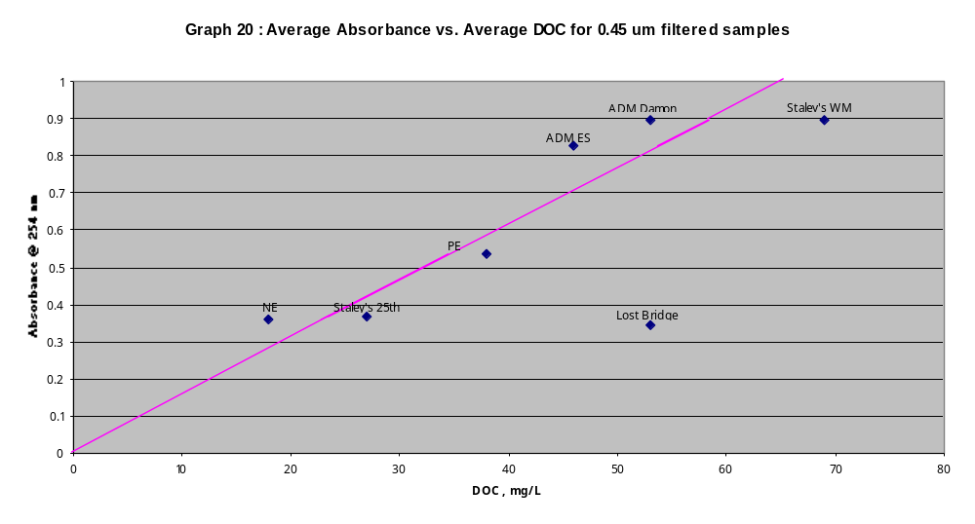

The situation with the nitrification effluent sample, NE, is different. While NE has an average absorbance as high as LB’s absorbance, its DOC concentration is about 1/3 of that of LB. As Graph 20 demonstrates, NE’s average absorbance has better correlation with its DOC concentration than LB. The main cause for NE to have such a large average SUVA value, which signifies its large degree of aromaticity, is its very low average DOC concentration. The reason why the nitrification effluent’s DOC concentration has dropped to such a low level is because of removal of major organic compounds such as sugars, proteins, and fats during treatments in the primary and secondary processes. At the same time other materials that can cause UV light blocking or scattering stay in the wastewater throughout the treatment process. The relatively high average absorbance of the nitrification effluent, compared to its very low DOC content, is therefore due to these materials. These materials may consist of aromatic/humic compounds or turbidity causing colloidal matter.

Primary effluent has a SUVA value that is intermediate between the LB and NE SUVA values. From the data in Table 12, the sanitary district treatment process between the PE and NE sample sites removes 52.6 % of DOC (38 mg/L vs. 18 mg/L) but only 32.9 % of the absorbance (0.535 vs. 0.359). This again suggests that in this part of the treatment process the organic carbon that is being more readily oxidized is of a non-aromatic nature such as sugars, starches, colloids, and amino acids without aromatic side chains. It can also be indicative of the presence of stable, refractory, UV absorbing humic substances in NE.

Phase VII – Relationship between Turbidity and UV Absorbance at 254 nm

In 23 trials during October-December of 2005, the turbidity and absorbance of NE samples before and after filtration were measured and compared against each other to determine the extent of the effect of suspended solids and turbidity removal on the absorbance of the samples. The data and results of this investigation are given in Table 13. Average reduction in turbidity of NE samples after removal of suspended solids was 96.5 %. This high reduction in turbidity upon filtration indicates that suspended solids cause most turbidity in NE and not dissolved substances. On the other hand, the low average % reduction in absorbance, 5.7 %, after filtration, indicates that the vast majority of absorption (94.3%) by NE is due to its dissolved solids content. The dissolved solids in NE may include molecules or colloidal particles. Because turbidity is very low in the 0.45 micron filtered NE, this suggests that light scattering colloids may not be a major cause of light blockage in NE.

Table 13. % Reduction in Turbidity and Absorbance of NE due to Suspended

Solids Removal
Sample Date | Turbidity of unfiltered NE (NTU) | Turbidity of 0.45 micron filtered NE  (NTU) | %Reduction in Turbidity | Absorbance of unfiltered NE at 254 nm | Absorbance of 0.45 micron filtered NE at 254 nm | % Reduction in Absorbance
10/18/05 | 7.9 | 0.31 | 96.1 | 0.505 | 0.461 | 8.7
19 | 5.5 | 0.38 | 93.1 | 0.504 | 0.457 | 9.3
20 | 6.4 | 0.39 | 93.9 | 0.495 | 0.453 | 8.5
21 | 6.1 | 0.18 | 97.0 | 0.265 | 0.233 | 12.1
24 | 3.9 | 0.17 | 95.6 | 0.391 | 0.372 | 4.9
25 | 3.8 | 0.16 | 95.8 | 0.415 | 0.395 | 4.8
26 | 3.2 | 0.19 | 94.1 | 0.407 | 0.390 | 4.2
11/11/05 | 3.9 | 0.16 | 95.9 | 0.358 | 0.346 | 3.4
14 | 3.7 | 0.13 | 96.5 | 0.374 | 0.357 | 4.5
15 | 4.5 | 0.13 | 97.1 | 0.368 | 0.350 | 4.9
16 | 4.1 | 0.14 | 96.6 | 0.300 | 0.285 | 5.0
17 | 5.1 | 0.14 | 97.3 | 0.343 | 0.327 | 4.7
18 | 4.3 | 0.13 | 97.0 | 0.349 | 0.333 | 4.6
21 | 4.8 | 0.14 | 97.1 | 0.379 | 0.359 | 5.3
22 | 5.1 | 0.12 | 97.6 | 0.378 | 0.361 | 4.5
23 | 5.0 | 0.12 | 96.6 | 0.376 | 0.355 | 5.6
28 | 6.1 | 0.16 | 97.4 | 0.333 | 0.308 | 7.5
29 | 4.7 | 0.12 | 97.4 | 0.234 | 0.217 | 7.3
12/02/05 | 5.1 | 0.13 | 97.5 | 0.321 | 0.305 | 5.0
05 | 5.2 | 0.13 | 97.5 | 0.337 | 0.321 | 4.7
06 | 4.3 | 0.14 | 96.7 | 0.331 | 0.317 | 4.2
27 | 3.4 | 0.13 | 96.2 | 0.329 | 0.317 | 3.6
30 | 3.5 | 0.16 | 95.4 | 0.325 | 0.311 | 4.3
Average | 4.8 | 0.17 | 96.5 | 0.366 | 0.345 | 5.7

New laboratory data (Table 14) reinforces the hypothesis that it is molecules more than colloids that are responsible for the vast majority of UV₂₅₄ light blocking in the nitrification effluent. This table shows that virtually all the turbidity can be removed (98.4 %) when NE is passed through a 0.02 micron filter but only 5.4 % of NE’s absorbance can be removed when passed through this filter. Since colloids scatter light and almost no light scattering occurred in the 0.02 micron filtered NE sample, it can be reasoned that colloids are of little consequence in the 0.02 micron filtered NE sample. Thus the significant absorbance that remains in the 0.02 micron filtered NE sample (94.6%) must come from chromophore-containing refractory molecules such as fulvic and humic acids.

Table 14. Turbidity and Absorbance Removal in Serially Filtered Nitrification Effluent Sample

 | Unfiltered NE | 0.45 μm filtered NE | 0.22 μm filtered NE | 0.02 μm filtered NE | Overall % Removal from unfiltered to 0.02 μm filtered
Turbidity | 4.9 | 0.16 | 0.13 | 0.08 | 98.4
Absorbance | 0.331 | 0.317 | 0.317 | 0.313 | 5.4

Phase VIII – Presence and effect of colloids and humic substances on UV absorption at 254 nm

Because colloidal dispersions and large polar molecules such as fulvic and humic acid have characteristic reactions towards various coagulants, these reactions can be used to verify the presence of such entities in a sample. In the following experiments, samples of the nitrification effluent were separately treated with two coagulants and affinity of the solids in the samples towards the coagulants was determined. The tests were performed on unfiltered instead of filtered NE because: 1) it was shown in a pilot experiment that there was no difference in the % removal of absorbance in NE whether or not the sample had been filtered prior to adding coagulant, and 2) to utilize coagulants in the SDD plant in order to correct low % UVT problems would dictate their use with unfiltered nitrification effluent.

From the two coagulants tested, ferric chloride was found to remove a higher percentage of absorbance than aluminum chloride. The most effective dose for ferric chloride was found to be 0.11 grams per 100 mL of NE with a 68.5 % reduction in absorbance compared to an average 52.8 % removal with aluminum chloride at a dosage of 0.09 grams per 100 mL. These dosages are in terms of the hexahydrated coagulants. If given in terms of the neat coagulant, the optimum concentrations would be 0.066 and 0.050 grams per 100 mL respectively. Coagulation reactions with both coagulants are pH dependent and less coagulant is needed if pH lowering is assisted by acid addition.

After treatment with ferric chloride at the optimal dose and subsequent filtration to remove small, unsettled flocs, all visible color was also removed. From a literature search it was found that ferric chloride is well known for its ability to remove colloids, humic substances and color but is unable to remove smaller sized molecules such as the micropollutants atrazine, geosmin, and 2-methylisoborneol (2-MIB) ²². Because the results from Phase VII show little colloid involvement in NE’s high UV₂₅₄ absorbance, the conclusion drawn is that fulvic and humic acid and similar charged molecules were the main things removed by coagulation. The 30 % of NE absorbance that could not be removed by ferric chloride coagulation may be a wide range of small, molecular micropollutants. Summary of results are given in Tables 15 and 16.

Table 15. Percent Reduction in NE Absorbance with Varying Amounts of Ferric Chloride Hexahydrate Added
g FeCl_{3.} 6H₂O per100mL of NE | pH of  treated  NE | Absorbance untreated  unfiltered  NE | Absorbance treated NE after 0.45 micron filtration | % reduction in Absorbance
0.115 | 4.01 | 0.391 | 0.137 | 65.0
0.112 | 4.39 | 0.391 | 0.129 | 67.0
0.110 | 4.51 | 0.391 | 0.123 | 68.5
0.105 | 4.91 | 0.391 | 0.129 | 67.0
0.100 | 5.23 | 0.391 | 0.135 | 65.5
0.000 | 8.30 | 0.391 | 0.372 | 4.9

Table 16. Percent Reduction in NE Absorbance with Varying Amounts of Aluminum Chloride Hexahydrate Added

g AlCl3. 6H2O per 100 mL of NE | pH of treated NE | Absorbance  unfiltered,  untreated NE | Absorbance treated NE after .45 micron filtration | % reduction in Absorbance
0.100 | 5.58 | 0.396 | 0.195 | 50.8
0.100 | 4.59 | 0.386 | 0.190 | 50.8
0.090 | 5.71 | 0.405 | 0.206 | 49.1
0.090 | 6.02 | 0.417 | 0.210 | 49.6
0.090 | 5.51 | 0.405 | 0.194 | 52.1
0.090 | 5.71 | 0.461 | 0.212 | 54.0
0.090 | 5.18 | 0.419 | 0.184 | 56.1
0.080 | 6.04 | 0.405 | 0.220 | 45.7
0.080 | 6.44 | 0.417 | 0.222 | 46.8
0.080 | 6.10 | 0.405 | 0.206 | 49.1
0.080 | 5.99 | 0.461 | 0.224 | 51.4
0.080 | 5.65 | 0.419 | 0.192 | 54.2
0.070 | 6.19 | 0.405 | 0.230 | 43.2
0.070 | 6.48 | 0.417 | 0.236 | 43.4
0.070 | 6.27 | 0.405 | 0.220 | 45.7
0.070 | 6.17 | 0.461 | 0.241 | 47.7
0.070 | 5.94 | 0.419 | 0.206 | 50.8

It was also noted that when NE is diluted by rainfall, the dosing amounts of inorganic coagulants are reduced. For example, a 10/21/05 NE grab sample which had been diluted by much rainfall used only 0.055 grams ferric chloride hexahydrate per 100 mL of NE to achieve maximum absorbance reduction. Figure 3 on page 35 shows the visual effect of coagulation on nitrification effluent.

Figure 3. Visual Effect of Coagulation on Nitrification Effluent

Ferric Chloride Untreated Aluminum Chloride
Treated NE NE Treated NE
↓ ↓ ↓

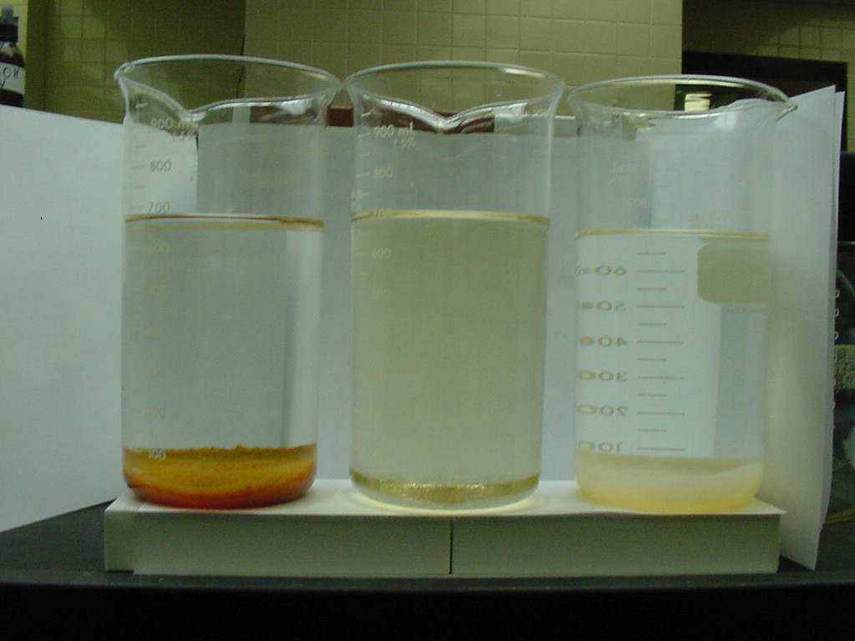

As an addendum to the coagulation research, organic nitrogen removal by ferric chloride coagulation was studied to see what % organic nitrogen was removed when the most effective dose of FeCl_{3.} 6H₂O for UV absorbance removal was added. Table 17 below shows that the % reduction in absorbance roughly parallels the % reduction in organic nitrogen. It can not be said to what degree the reduction in organic nitrogen was responsible for the reduction in absorbance because there may certainly be other classes of UV absorbing compounds in the waste stream that do not contain nitrogen that were removed by the ferric chloride coagulant during this experiment.

Table 17. % Reduction in NE Organic Nitrogen when Maximum Absorbance Reduction Achieved by Ferric Chloride Hexahydrate Coagulation

Sample Date | Grams ferric chloride added per 100 mL of NE | % Reduction in absorbance for ferric chloride treated NE vs. untreated NE | % Reduction in organic nitrogen for ferric chloride treated NE vs. untreated NE | pH of ferric chloride treated NE
11/17/2005 | 0.1083 | 70.0 | 73.6 | 4.60
11/21/2005 | 0.1187 | 68.6 | 62.5 | 4.99

Conclusion

After about a year of research on the compounds or factors responsible for low %UVTs in the SDD’s nitrification effluent, the following statements can be made:

1) Turbidity is not a significant cause of low % UVTs in the nitrification effluent.

2) Substances with minute diameters, 0.45 microns or smaller, cause about 94% of UV light absorption in the nitrification effluent.

3) Molecules with chromophores to a much greater extent than colloids are responsible for SDD’s low %UVTs in the nitrification effluent.

4) The compounds under greatest suspicion for causing low % UVTs in NE are fulvic and humic acid.

.
References cited :
¹ Silverstein, R.M., & Bassler, G.C., Spectrophotometric Identification of Organic Compounds, 2d ed., John Wiley & Sons Inc., New York, 1967.

² Popov, A. I. & Pflaum, R. T., Introductory Analytical Chemistry, D.C. Heath and Company, 1966.

³ U.S. EPA. 1986. Municipal Wastewater Disinfection Design Manual. EPA 625/1-86-021. U.S. Environmental Protection Agency, Cincinnati, OH.

⁴ Eaton, A.D., Clesceri, L.S., & Greenberg, A.E. Standard Methods for the Examination of Water and Wastewater. 19th ed. American Public Health Association. Washington, D.C. ,1995.

⁵ http://www.formsci.co.il/HPLC/SPE site.pdf

⁶ Guzzetta, Andrew. Reversed Phase HPLC Basics for LC/MS. IonSource, LLC 2001

⁷ http://www.piercenet.com

⁸ Shriner,R.L. & Fuson, R.C. 1964. The Systematic Identification of Organic Compounds. John Wiley & Sons, Inc.

⁹ http:www//.pearl.maine.edu/glossary/misc/doc.htm

¹⁰ http:www.stl-inc.com/analyticalservices/specialty%20services/Disinfection%20Byproduc…

¹¹ http://www.epa.gov/safewater/mdbp/coaguide.pdf

¹² Chin Y.P., Aiken G.R. and O’Loughlin E. 1994. Molecular weight, polydispersivity, and spectroscopic properties of aquatic humic substances. Environ. Sci. Technol. 28: 1853-1858.

¹³ Sawyer, C., 1960, Chemistry for Sanitary Engineers. McGraw-Hill Book Company, Inc.

¹⁴ Metcalf & Eddy. 1972. Wastewater Engineering: Collection, Treatment, Disposal. McGraw-Hill, Inc

¹⁵ Du, H., Fuh, R.A., Li, A., Corkan, A., Lindsey, J.S., “PhotochemCAD: A computer –aided design and research tool in photochemistry,” Photochemistry and Photobiology, 68, 141-142, 1998.

¹⁶ Kononova, M.M., Aleksandrova, I.V. Soils Fert. 22, 77, 1959

¹⁷ Rebhun, M. and Manka, J., “Classification of Organics in Secondary Effluents,” Environmental Science & Technology, 5, 606-609,1971.

¹⁸ http://www.livearth.com/faq.htm

¹⁹ http://www.ar.wroc.pl/~weber/kwasy2.htm

²⁰ Confer, D.R., Logan, B.E., Aiken, B.S., Kirchman, D.L. 1995. Measurement of dissolved free and combined amino acids in unconcentrated wastewaters using high performance liquid chromatography. Wat. Env. Research. 67, 118-125.

²¹ Steward, F.C. & Thompson. 1950. The Nitrogenous Constituents of Plants with Special Reference to Chromatographic Methods. Annual Review of Plant Physiology. Vol. 1, pages 233 – 264.

²² Freese,S.D., Nozaic D.J., Pryor, M.J., Rajogopaul, R., Trollip, D.L., and Smith, R.A. 2001. Enhanced coagulation: a viable option to advance treatment technologies in the South African context. Water Science and Technology: Water Supply, 1, No 1, pages 33-41.

Acknowledgements

The Research & Development Department would like to thank Larry Arnold and Donovan Brewner for their technical assistance in use of computer to prepare this report. We also would like to thank Scott Duncan for helping us with sample collection at the Lost Bridge Pumping Station.

